What I Built Today
We officially started the security phase today. Using the root AWS account for daily tasks is a massive security risk, so today was all about Identity and Access Management (IAM). I locked down the root account, enabled Multi-Factor Authentication (MFA), and created a dedicated Admin user for my day-to-day building.

Why This Matters
When I eventually deploy the backends for EstatePadi or my hardware prototypes like the self-balancing robot, I cannot afford a single compromised password taking down my entire architecture. By setting up IAM users and applying the principle of least privilege, I am ensuring that every component and user only has access to exactly what they need—and nothing more.

Step 1: Locking the Root Account
- The root account has absolute power over the environment, so the first move was enabling virtual MFA on it.
- Once that was secured, I essentially retired it. From now on, it is locked away for billing and account-level emergencies only.

Step 2: Setting up Groups and Users
To keep things clean and scalable, I avoided attaching permissions directly to a user.
- The Group: I created 3 groups (Developer, Manager and Analyst) and attached the respective managed policies to it.
- The User: I generated a new daily-driver IAM user for each of the groups (dev-user, manager-user, analyst-user). This gives me the power to build and deploy without ever exposing the root credentials.

Gotchas & Troubleshooting
- The Custom Login Link: IAM users cannot sign in through the standard root login page. I had to locate and save the specific 12-digit Account ID sign-in URL (or create an Account Alias) to log in as my new user.
- Password Policies: Setting a strict account-wide password policy (requiring symbols, numbers, and a minimum length) is a crucial first step before creating any users, otherwise, you risk deploying weak entry points.

Proof of Work
When I tried to create an S3 bucket in analyst-user
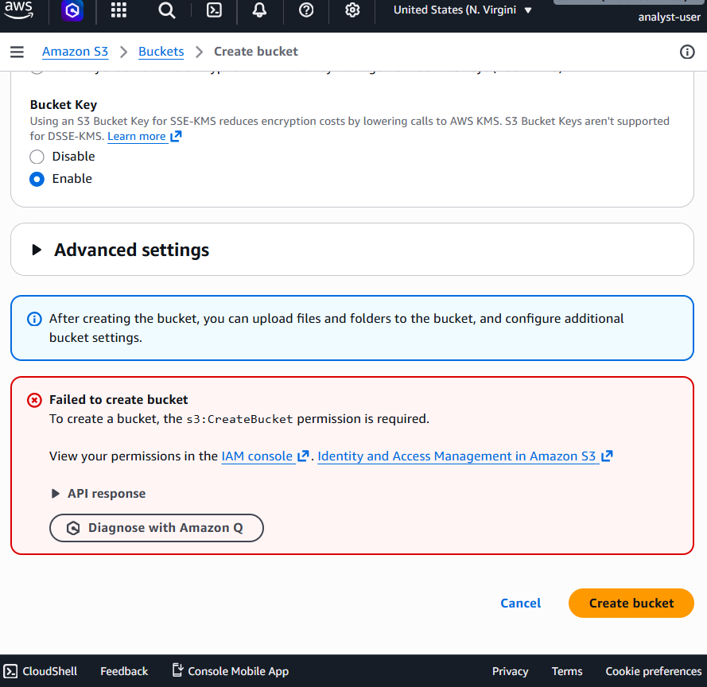
When I tried to launch an EC2 instance in manager-user
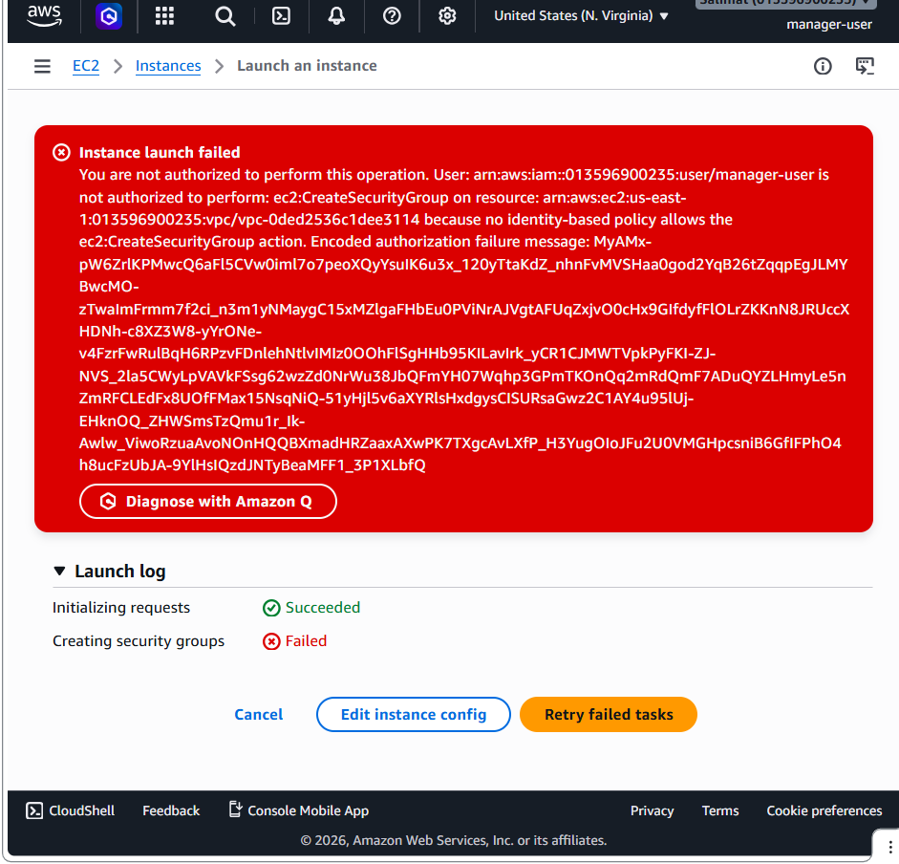

My IAM user group Checklist
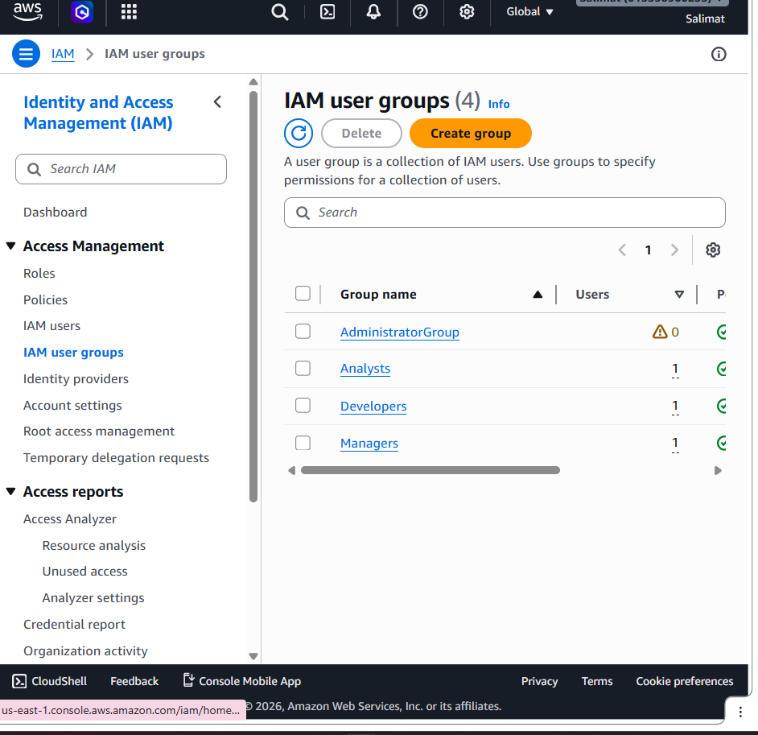

My IAM user Checklist
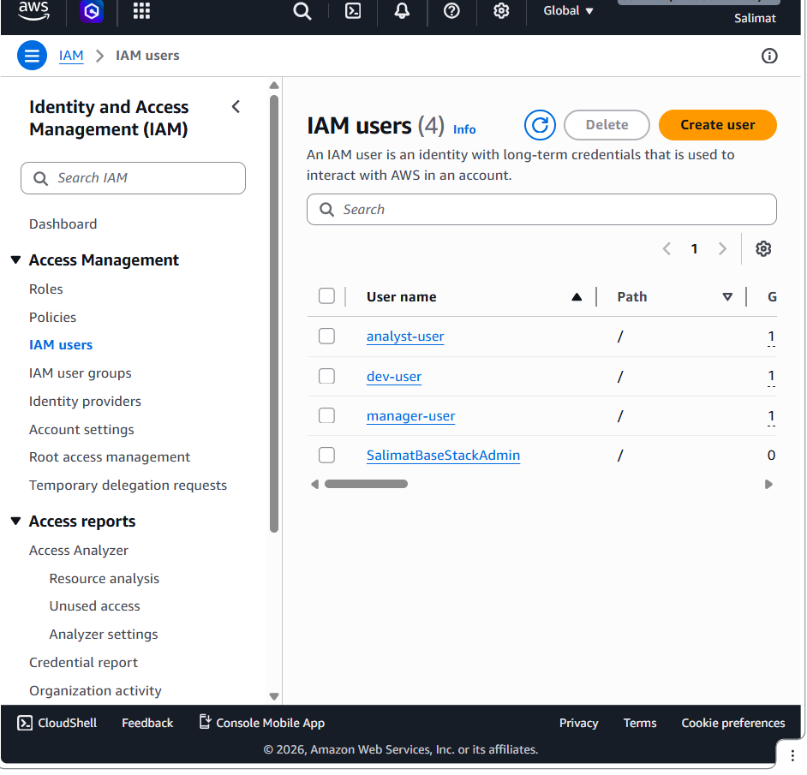

Creation of EC2-S3-ReadOnlyAccess
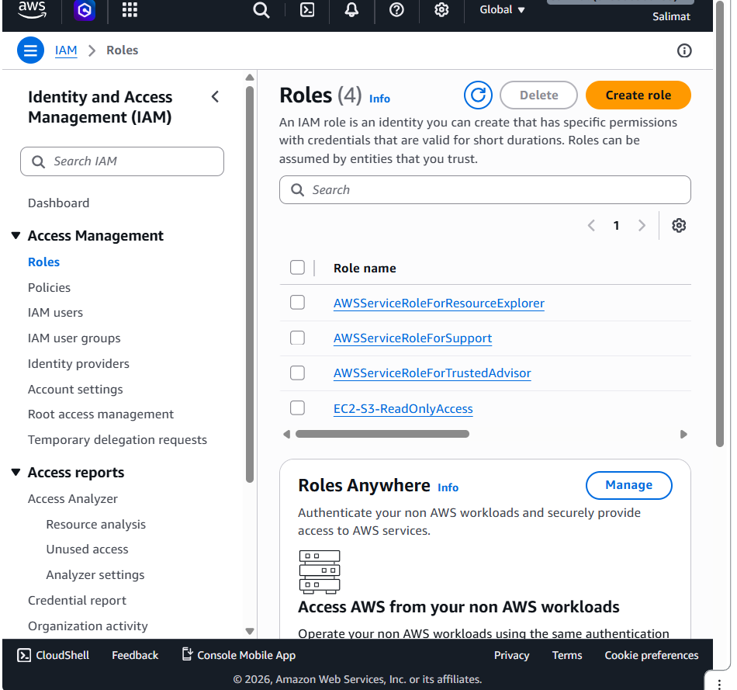

Creating the EC2-S3-ReadOnlyAccess Role
